**Virtual base class**

Virtual base classes are used in virtual inheritance in a way of preventing multiple “instances” of a given class appearing in an inheritance hierarchy when using multiple inheritances.

**Need for Virtual Base Classes:**  
Consider the situation where we have one class **A**. This class is **A** is inherited by two other classes **B** and **C**. Both these classes are inherited into another in a new class **D** as shown in figure below.

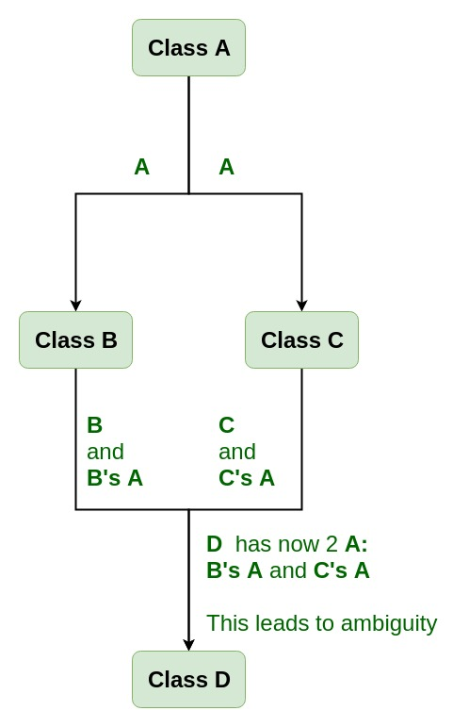

As we can see from the figure that data members/function of class **A** are inherited twice to class **D**. One through class **B** and second through class **C**. When any data / function member of class **A** is accessed by an object of class **D**, ambiguity arises as to which data/function member would be called? One inherited through **B** or the other inherited through **C**. This confuses compiler and it displays error.

**Example:** To show the need of Virtual Base Class in C++

|  |
| --- |
| #include <iostream>  using namespace std;    class A {  public:      void show()      {          cout << "Hello form A \n";      }  };    class B : public A {  };    class C : public A {  };    class D : public B, public C {  };    int main()  {      D object;      object.show();  } |

**Compile Errors:**

prog.cpp: In function 'int main()':

prog.cpp:29:9: error: request for member 'show' is ambiguous

object.show();

^

prog.cpp:8:8: note: candidates are: void A::show()

void show()

^

prog.cpp:8:8: note: void A::show()

**How to resolve this issue?**  
To resolve this ambiguity when class **A** is inherited in both class **B** and class **C**, it is declared as **virtual base class** by placing a keyword **virtual** as :

**Syntax for Virtual Base Classes:**

**Syntax 1:**

class B : virtual public A

{

};

**Syntax 2:**

class C : public virtual A

{

};

**Note:** **virtual** can be written before or after the **public**. Now only one copy of data/function member will be copied to class **C** and class **B** and class **A** becomes the virtual base class.  
Virtual base classes offer a way to save space and avoid ambiguities in class hierarchies that use multiple inheritances. When a base class is specified as a virtual base, it can act as an indirect base more than once without duplication of its data members. A single copy of its data members is shared by all the base classes that use virtual base.

**Example 1**

|  |
| --- |
| #include <iostream>  using namespace std;    class A {  public:      int a;      A() // constructor      {          a = 10;      }  };    class B : public virtual A {  };    class C : public virtual A {  };    class D : public B, public C {  };    int main()  {      D object; // object creation of class d      cout << "a = " << object.a << endl;        return 0;  } |

**Output:**

a = 10

**Explanation :**The class **A** has just one data member **a** which is **public**. This class is virtually inherited in class **B** and class **C**. Now class **B** and class **C** becomes virtual base class and no duplication of data member **a** is done.

**Example 2:**

|  |
| --- |
| #include <iostream>  using namespace std;    class A {  public:      void show()      {          cout << "Hello from A \n";      }  };    class B : public virtual A {  };    class C : public virtual A {  };    class D : public B, public C {  };    int main()  {      D object;      object.show();  } |

**Output:**

Hello from A